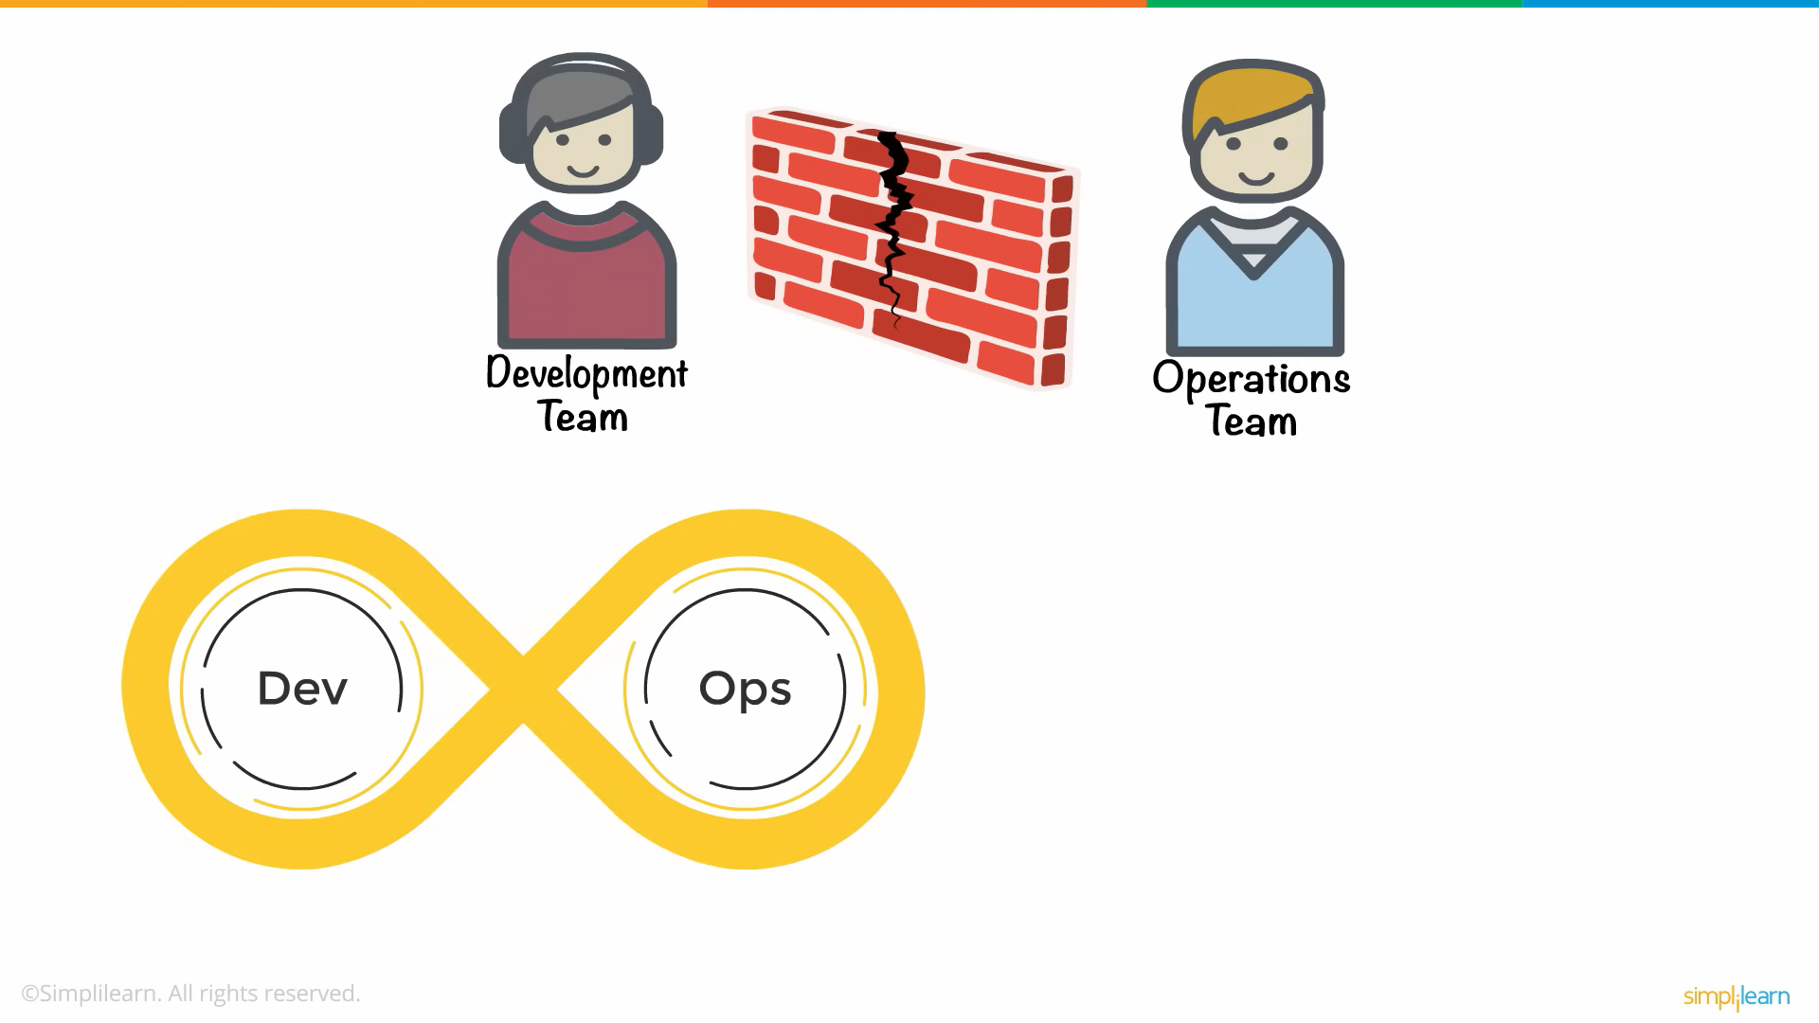

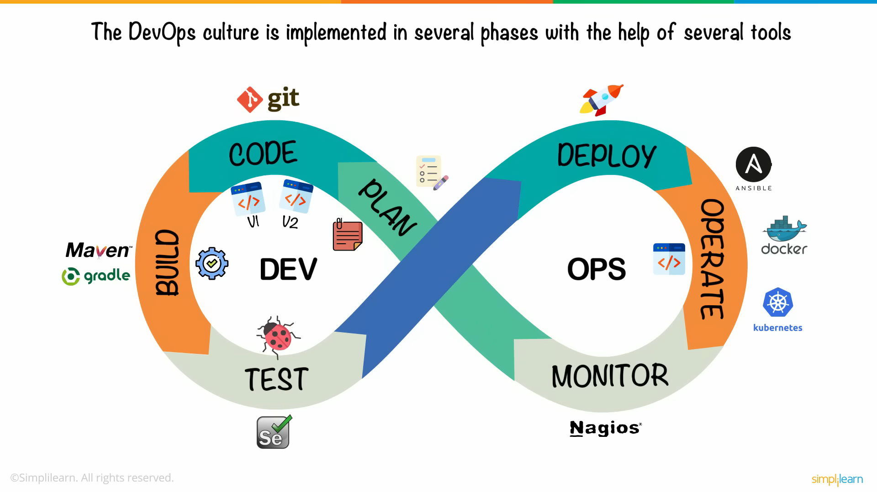

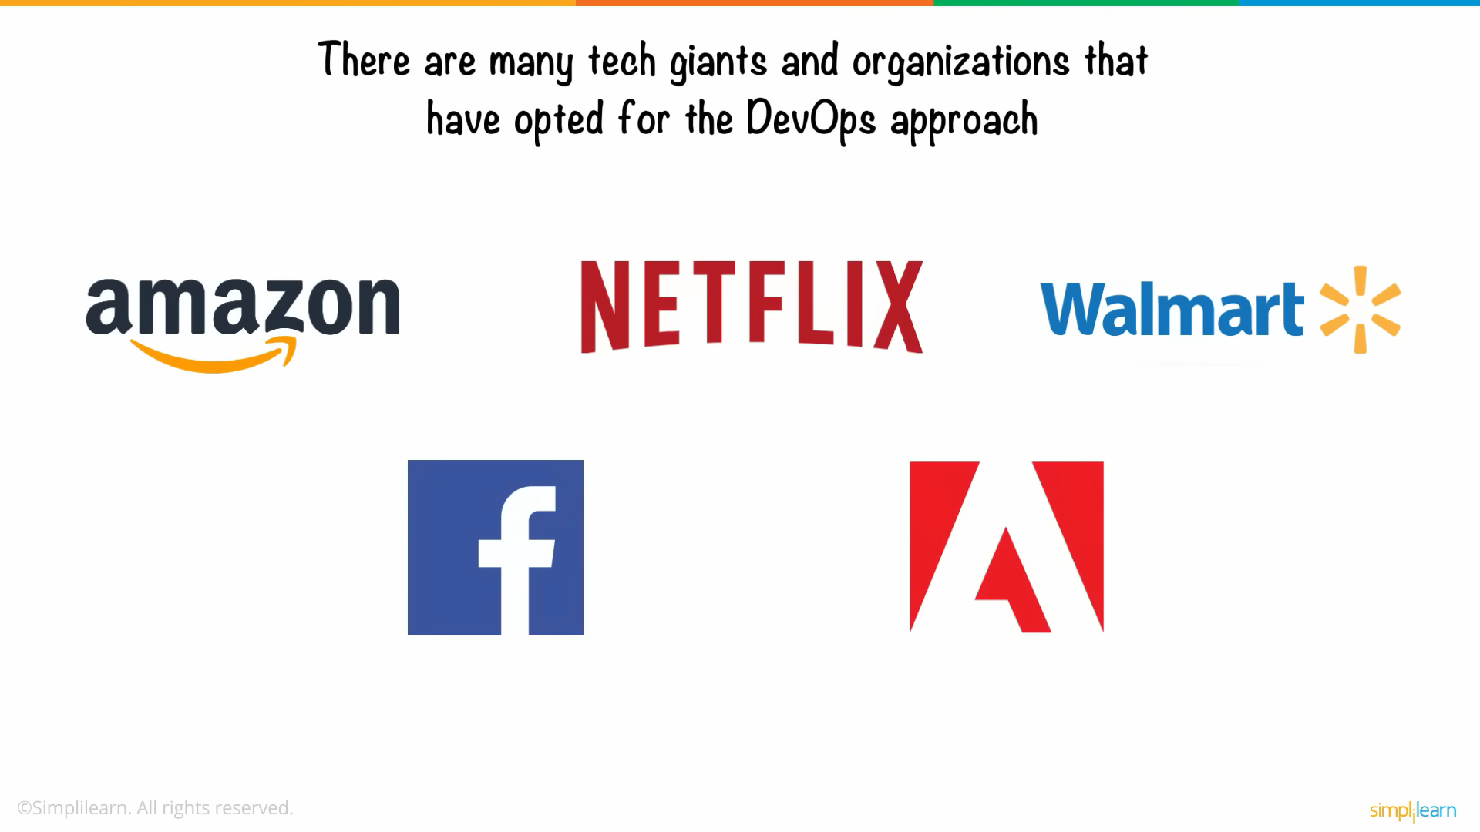

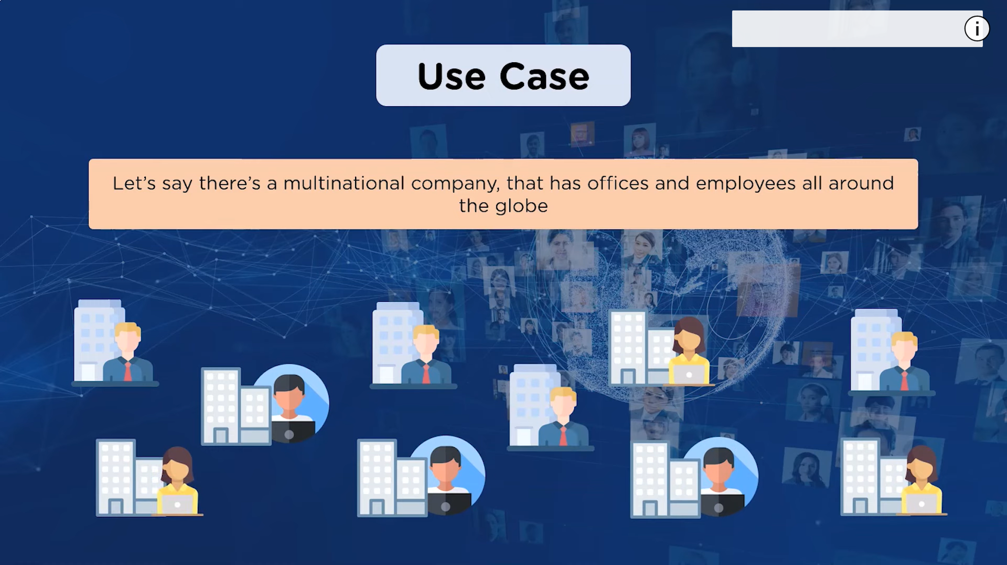

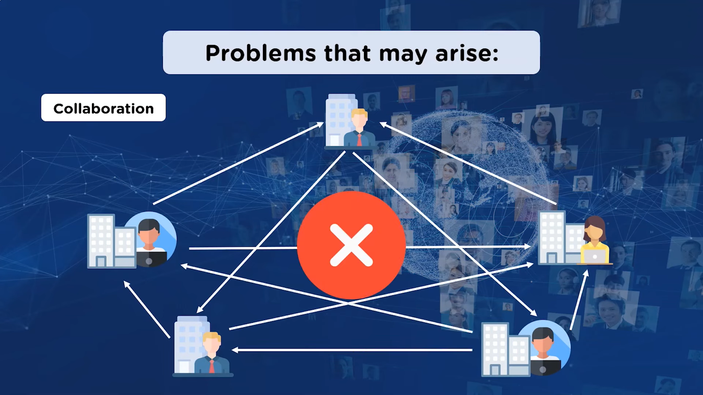

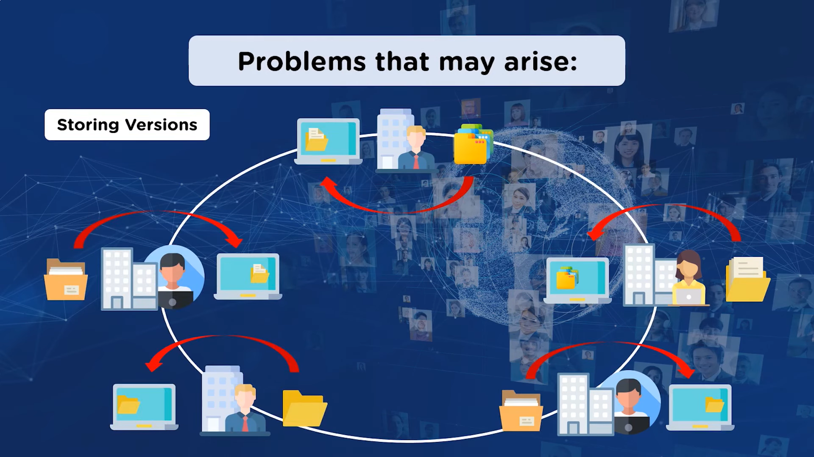

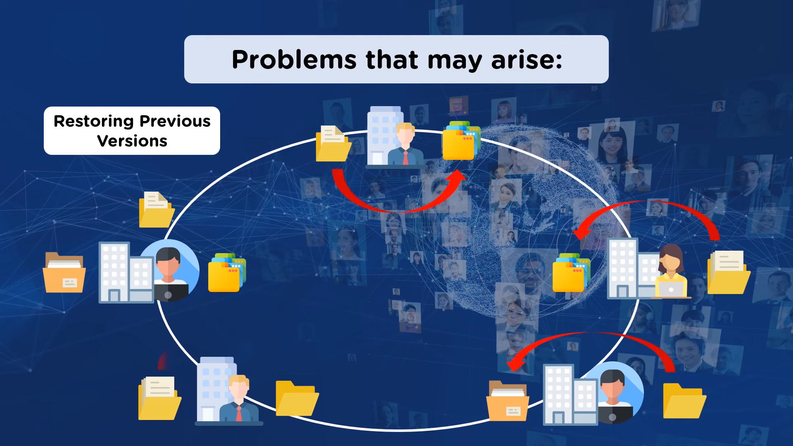

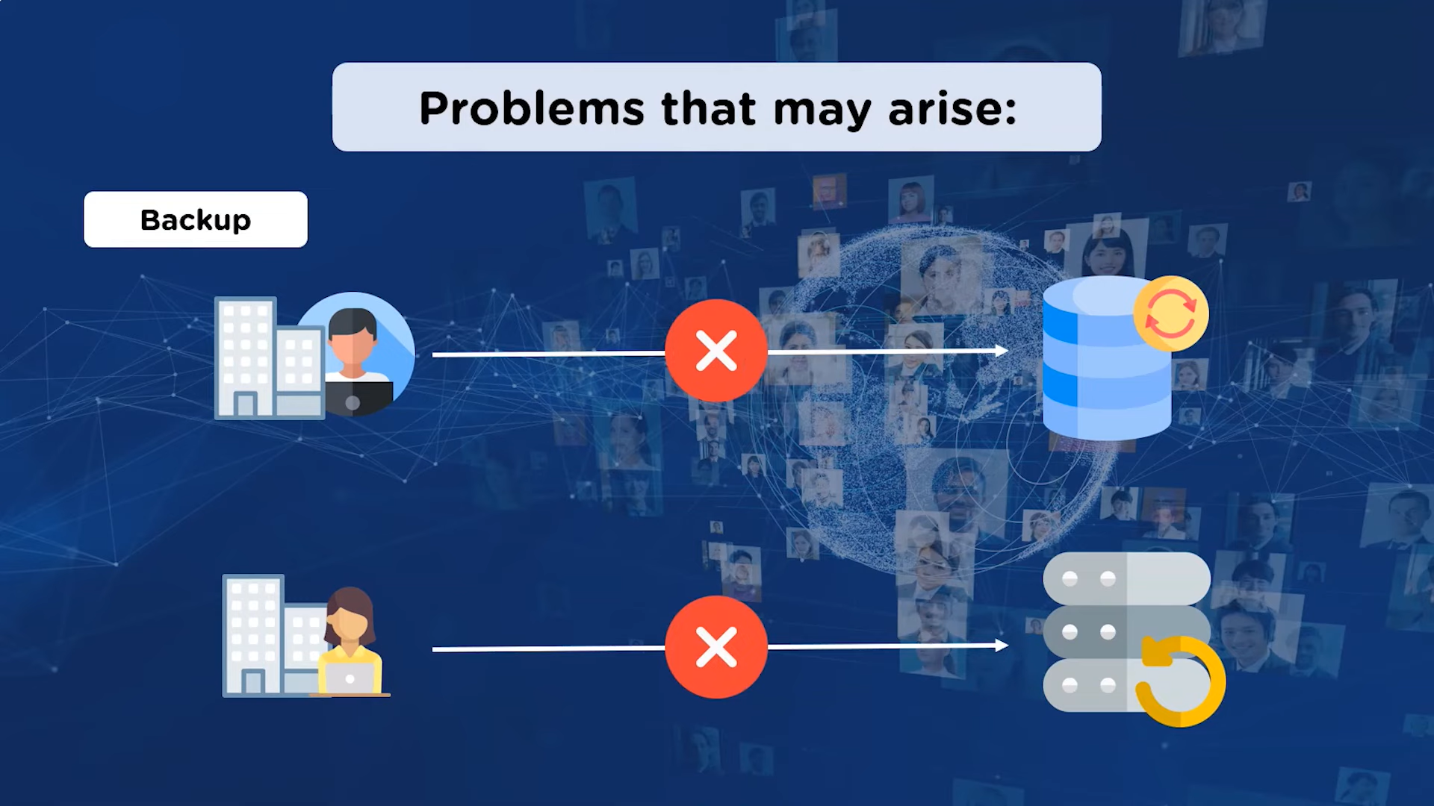

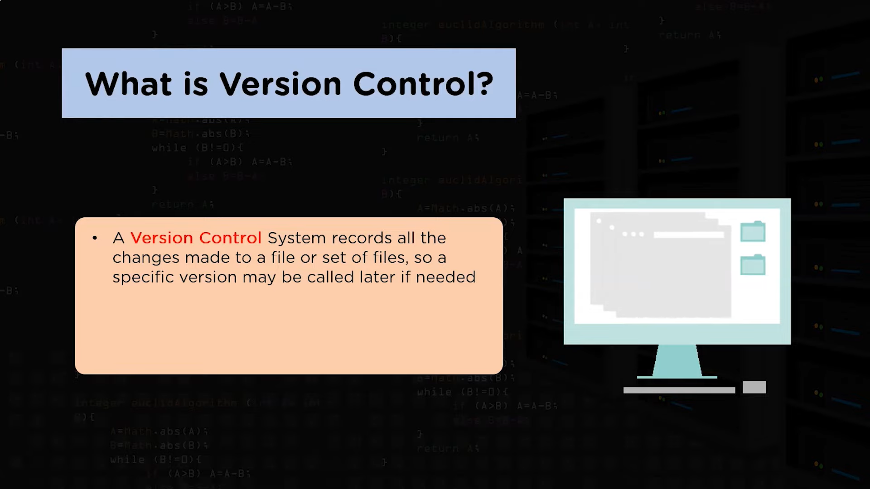

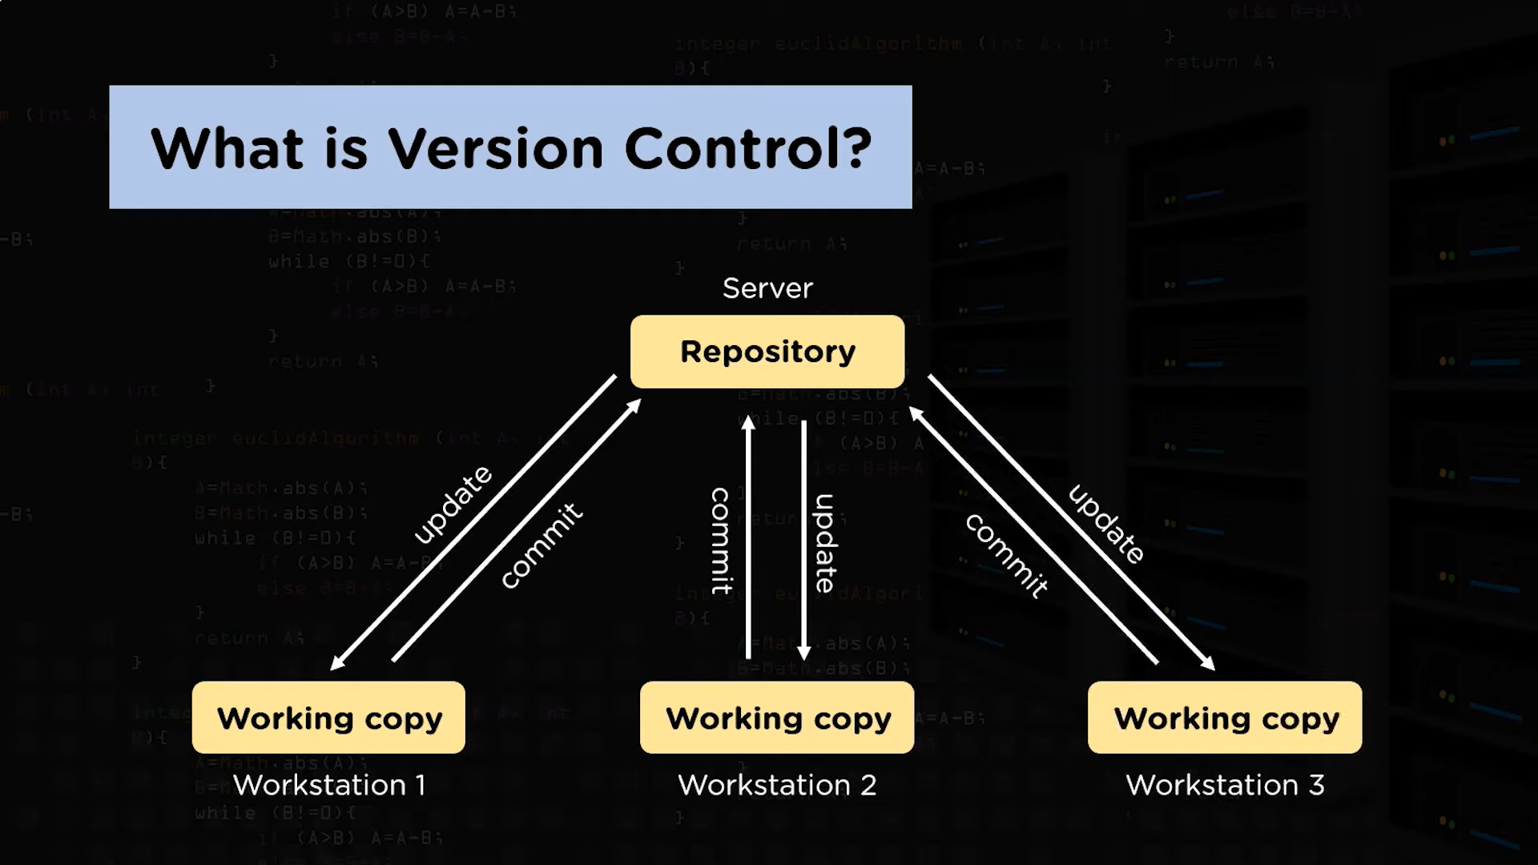

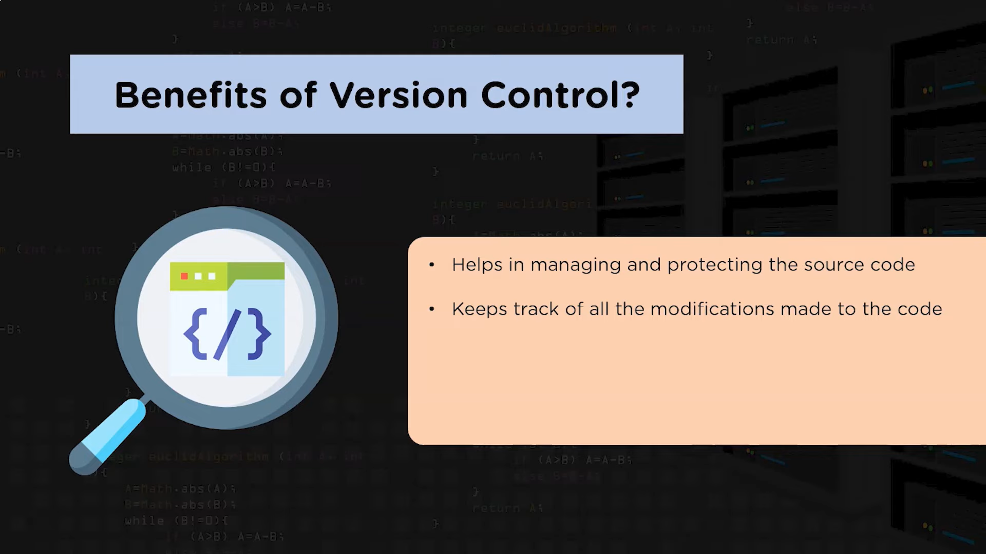

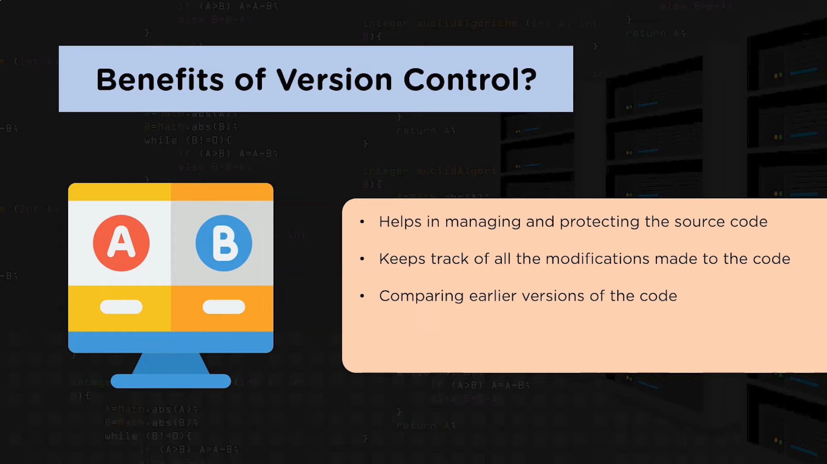

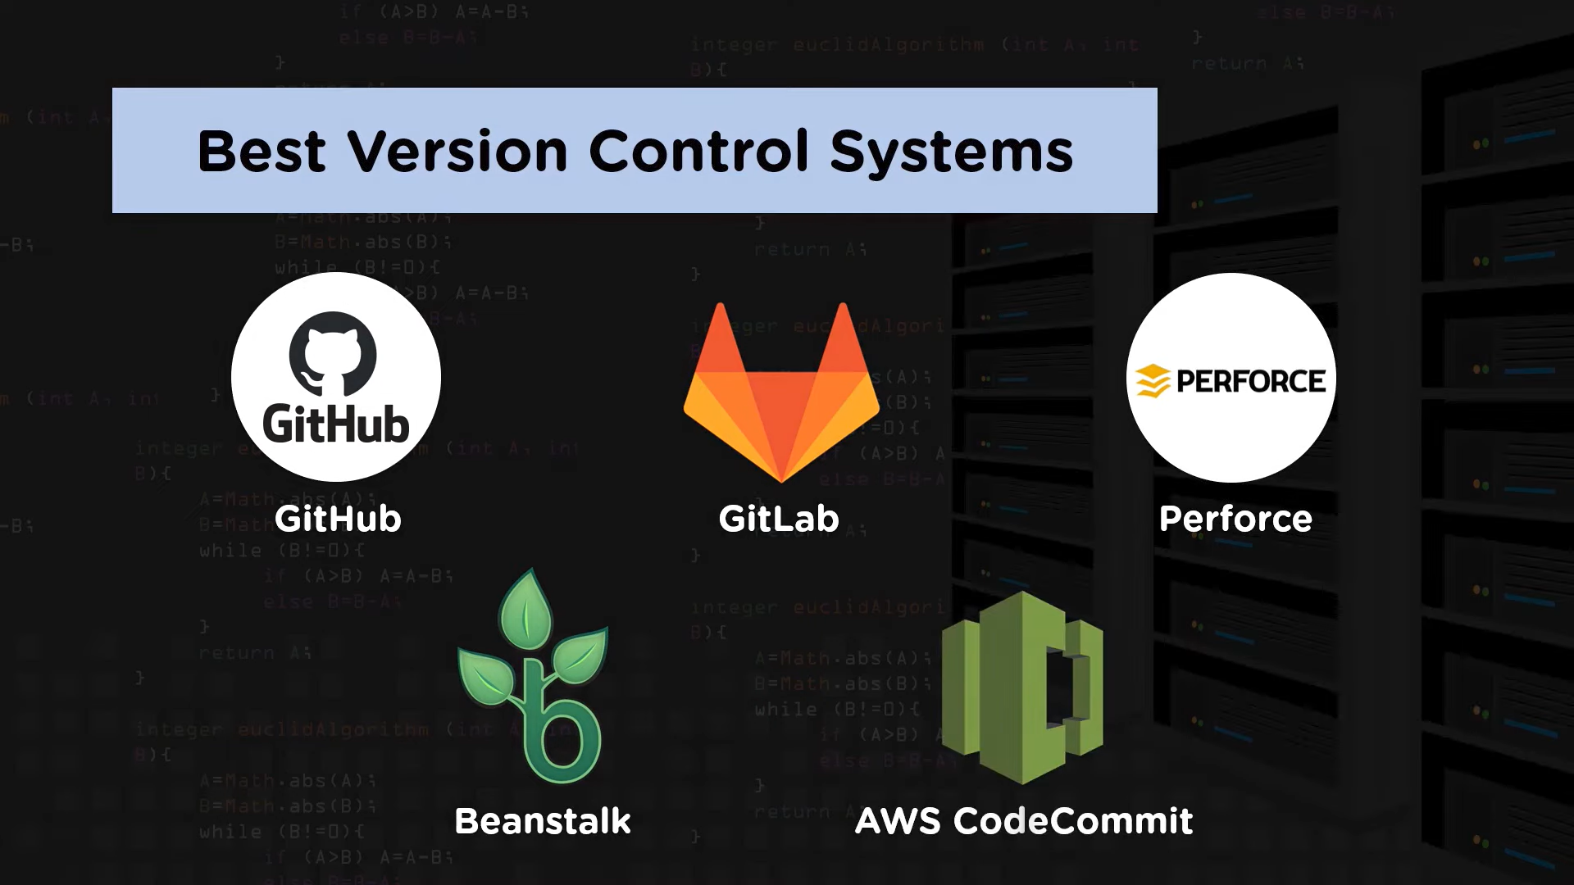

**Git:** Git is a distributed version control system for tracking changes in source code during software development. It is designed for coordinating work among programmers, but it can be used to track changes in any set of files. Its goals include speed, data integrity, and support for distributed, non-linear workflows.

**GitHub:** GitHub is a web-based Git repository hosting service, which offers all of the distributed revision control and source code management (SCM) functionality of Git as well as adding its own features.

| **S.No.** | **Git** | **GitHub** |
| --- | --- | --- |
| 1. | Git is a software. | GitHub is a service. |
| 2. | Git is a command-line tool | GitHub is a graphical user interface |
| 3. | Git is installed locally on the system | GitHub is hosted on the web |